UNL.13
UNL.13 | Upload 1000 customers in bulk

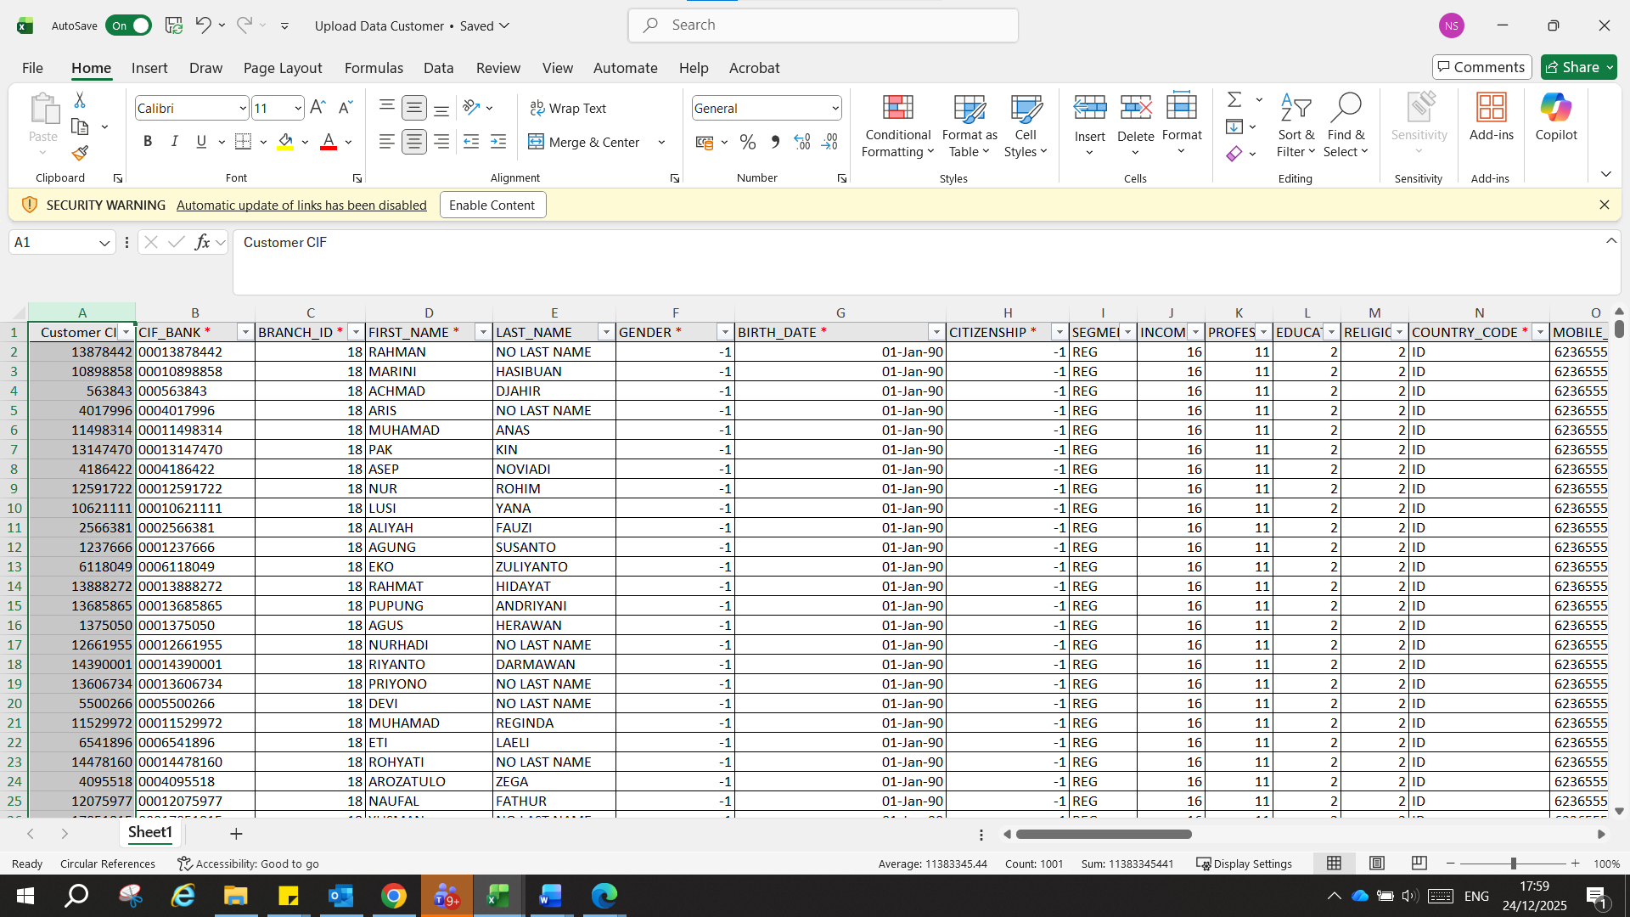
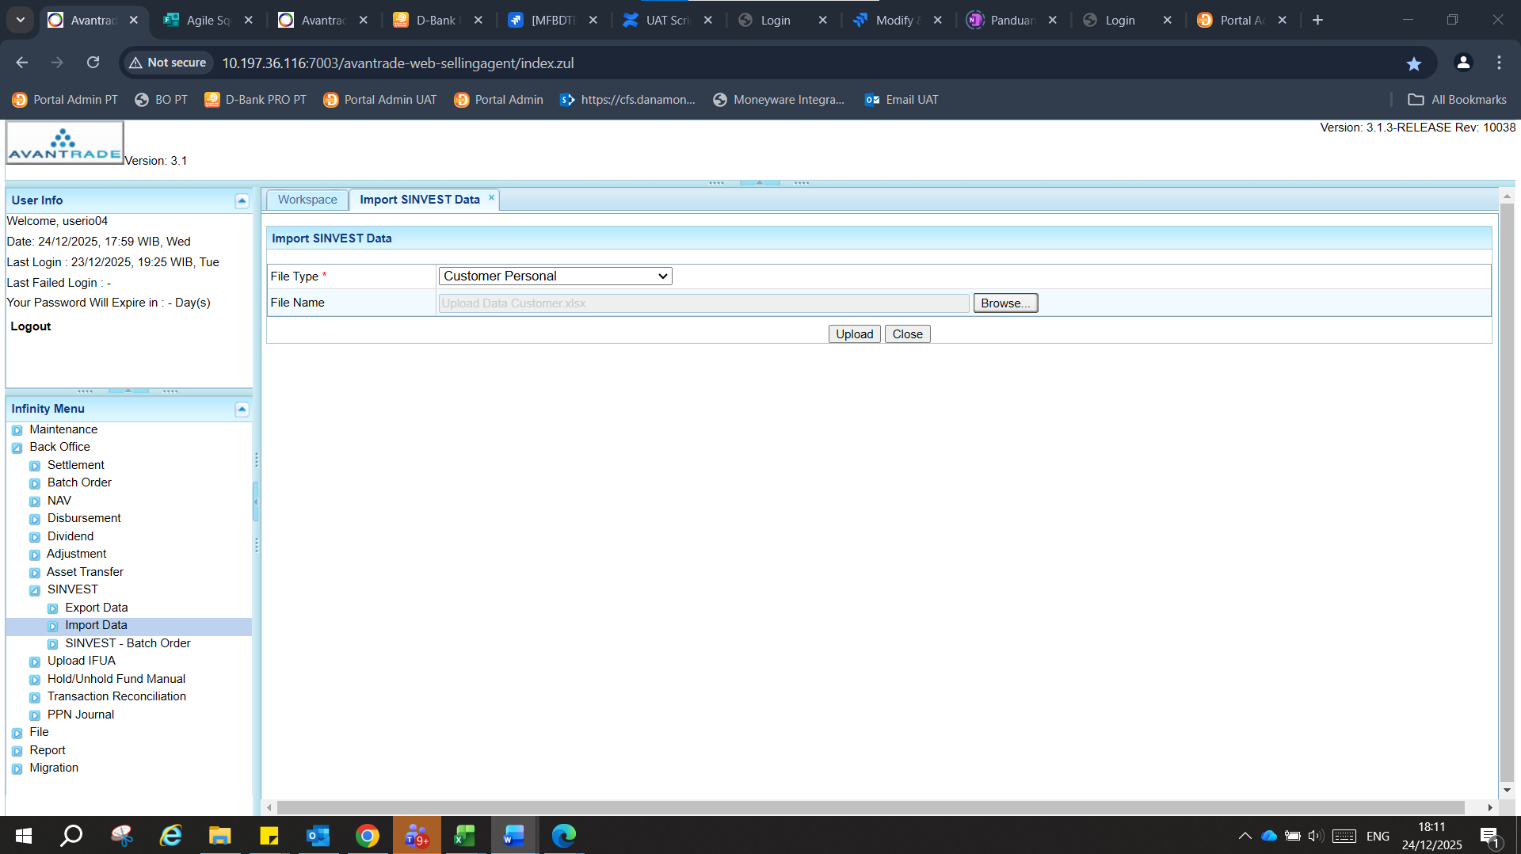
Defect:
CIF yg angkanya hampir sama, tidak bisa terupload, tag cif sama
