AVT - Upload Customer Personal Static - Validasi tidak berjalan pada beberapa kolom

- Risk Profile Question - Input pertanyaan melebihi total jawaban yang seharusnya ( Risk Profile Question = 10, Risk Profile Answer = 5 )
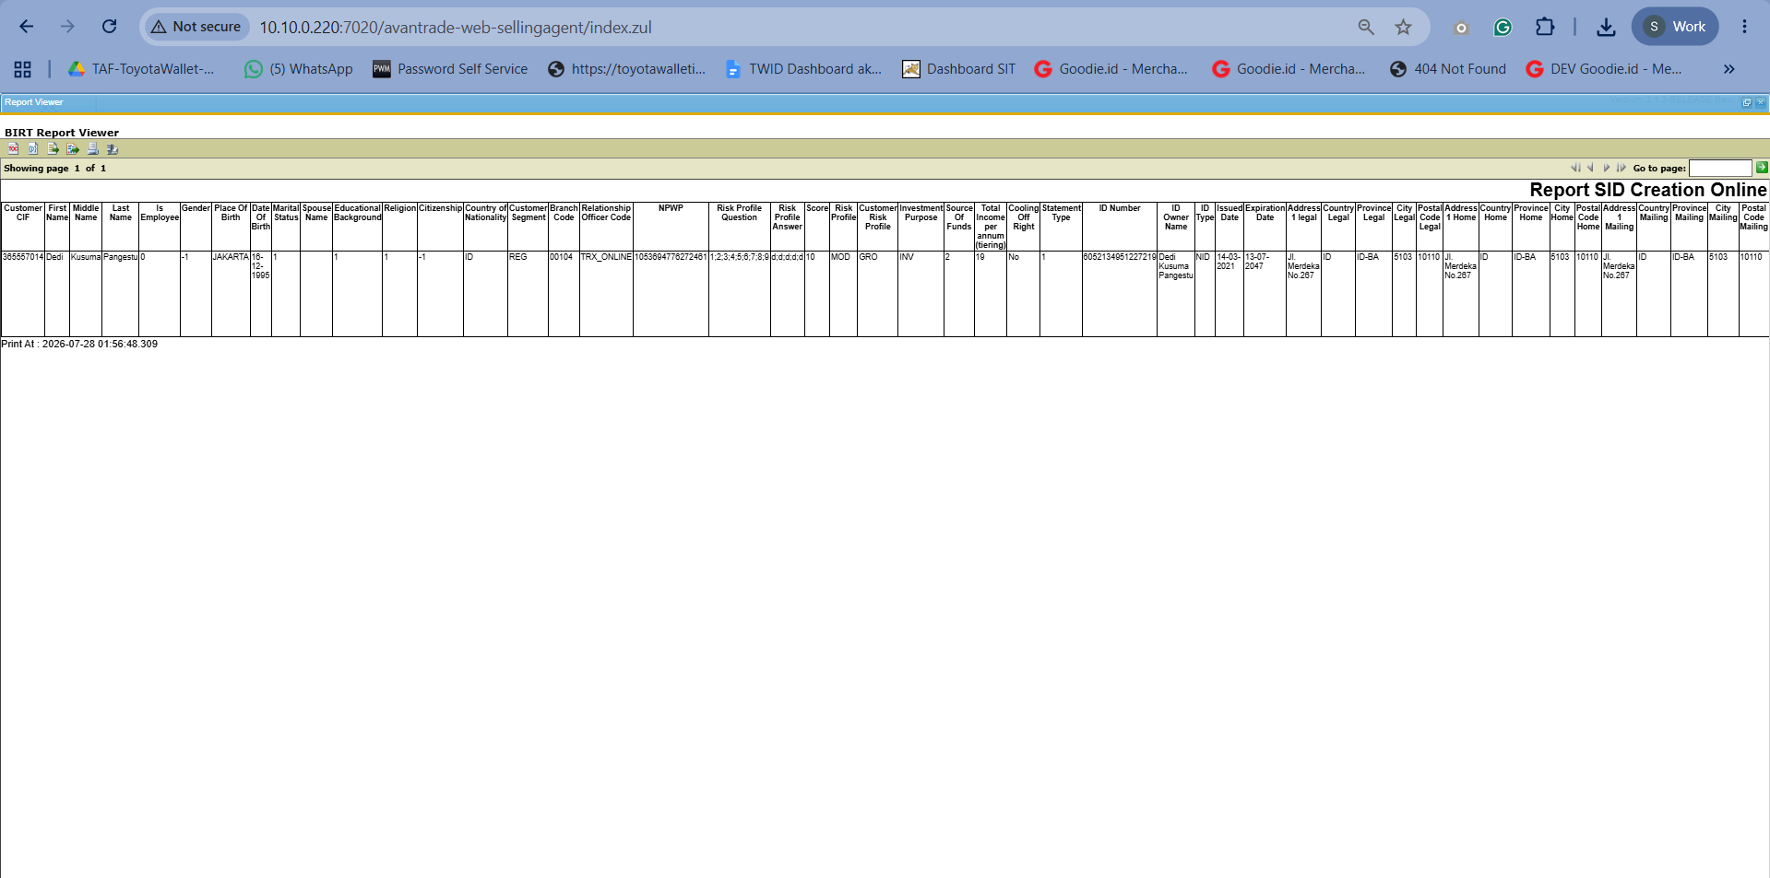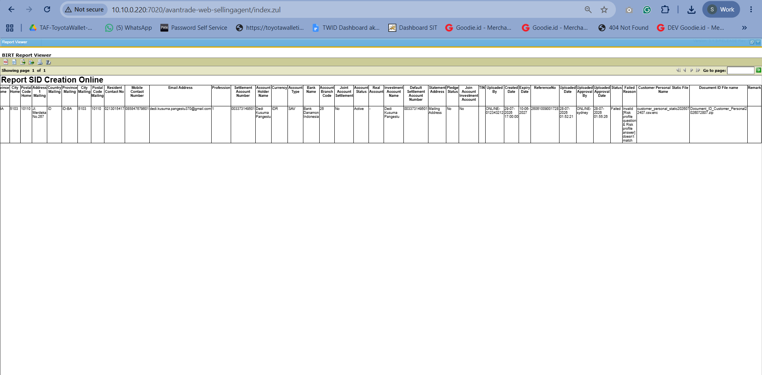

- Risk Profile Question - Input format pertanyaan tidak sesuai (Risk Profile Question = 1/2/3/4/5)
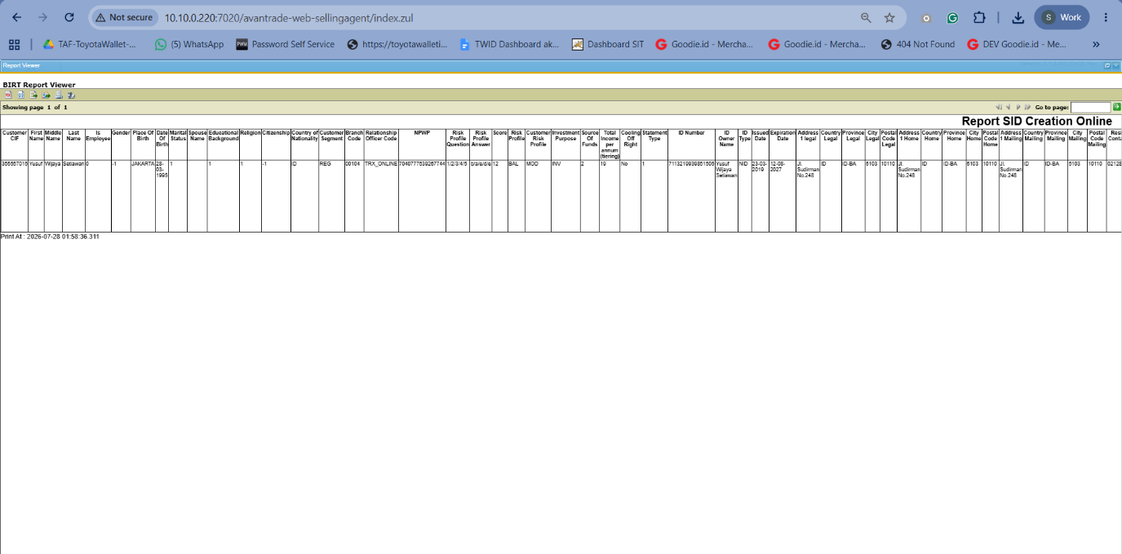
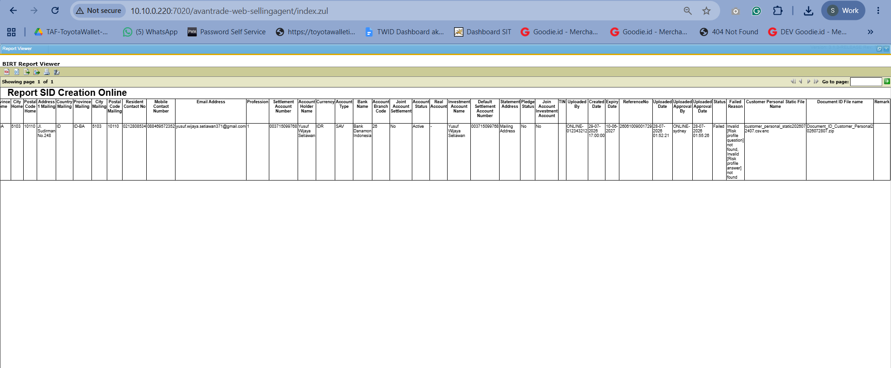

- Risk Profile Question - Input format pertanyaan dengan data Invalid (Risk Profile Question = a;b;c;d;e)
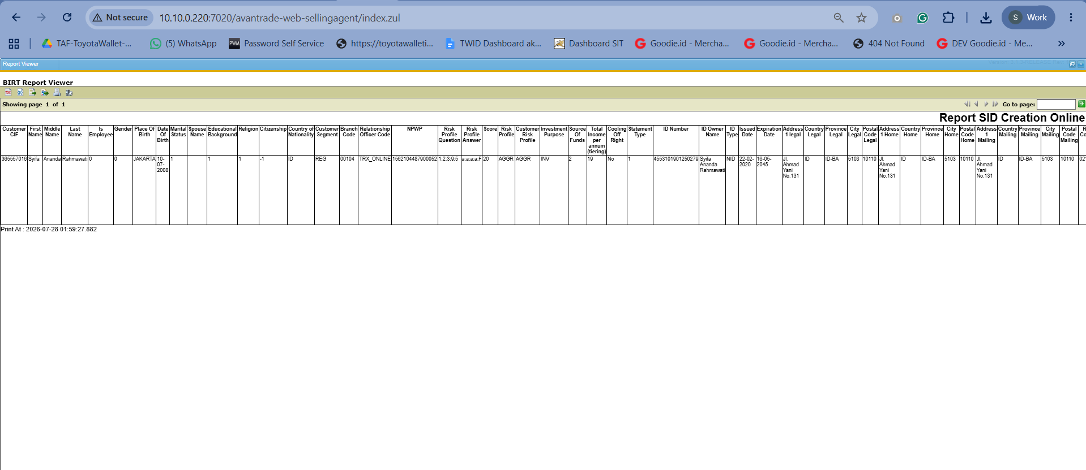
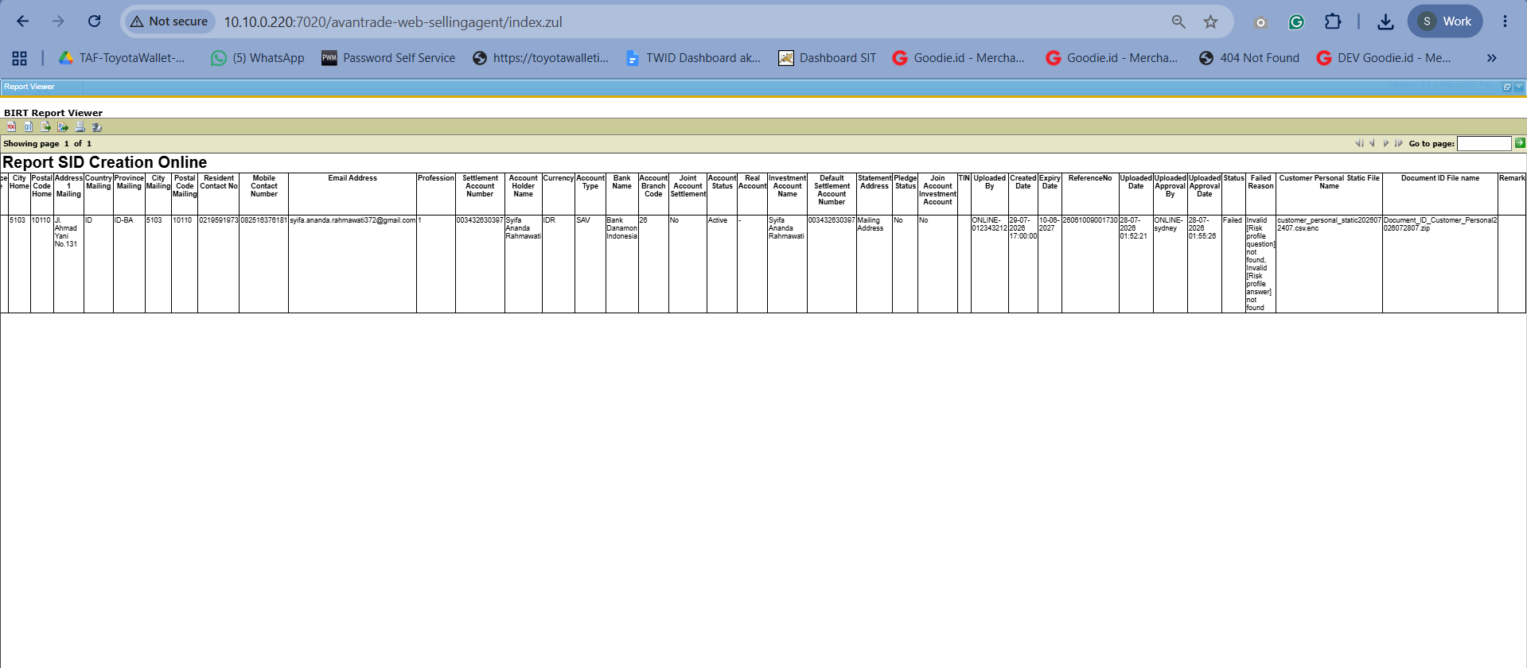

- Risk Profile Answer - Input jawaban melebihi total pertanyaan yang seharusnya ( Risk Profile Question total = 5, Risk Profile Answer = 10)
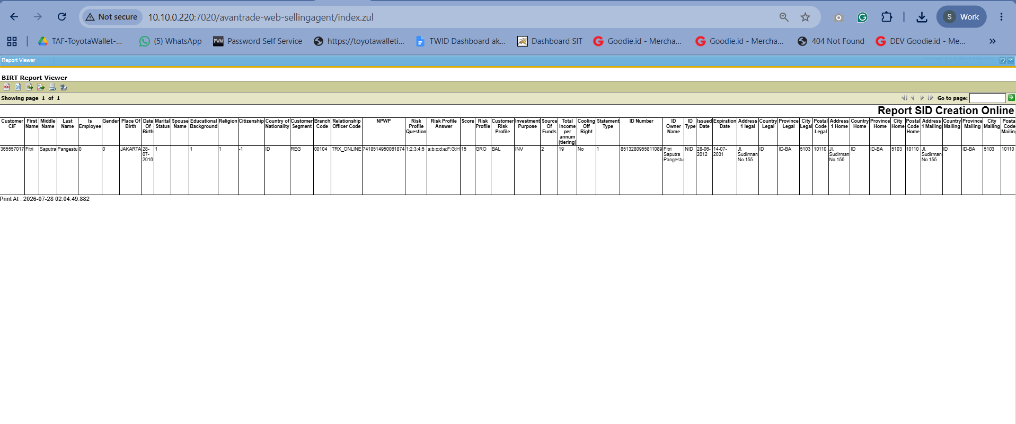
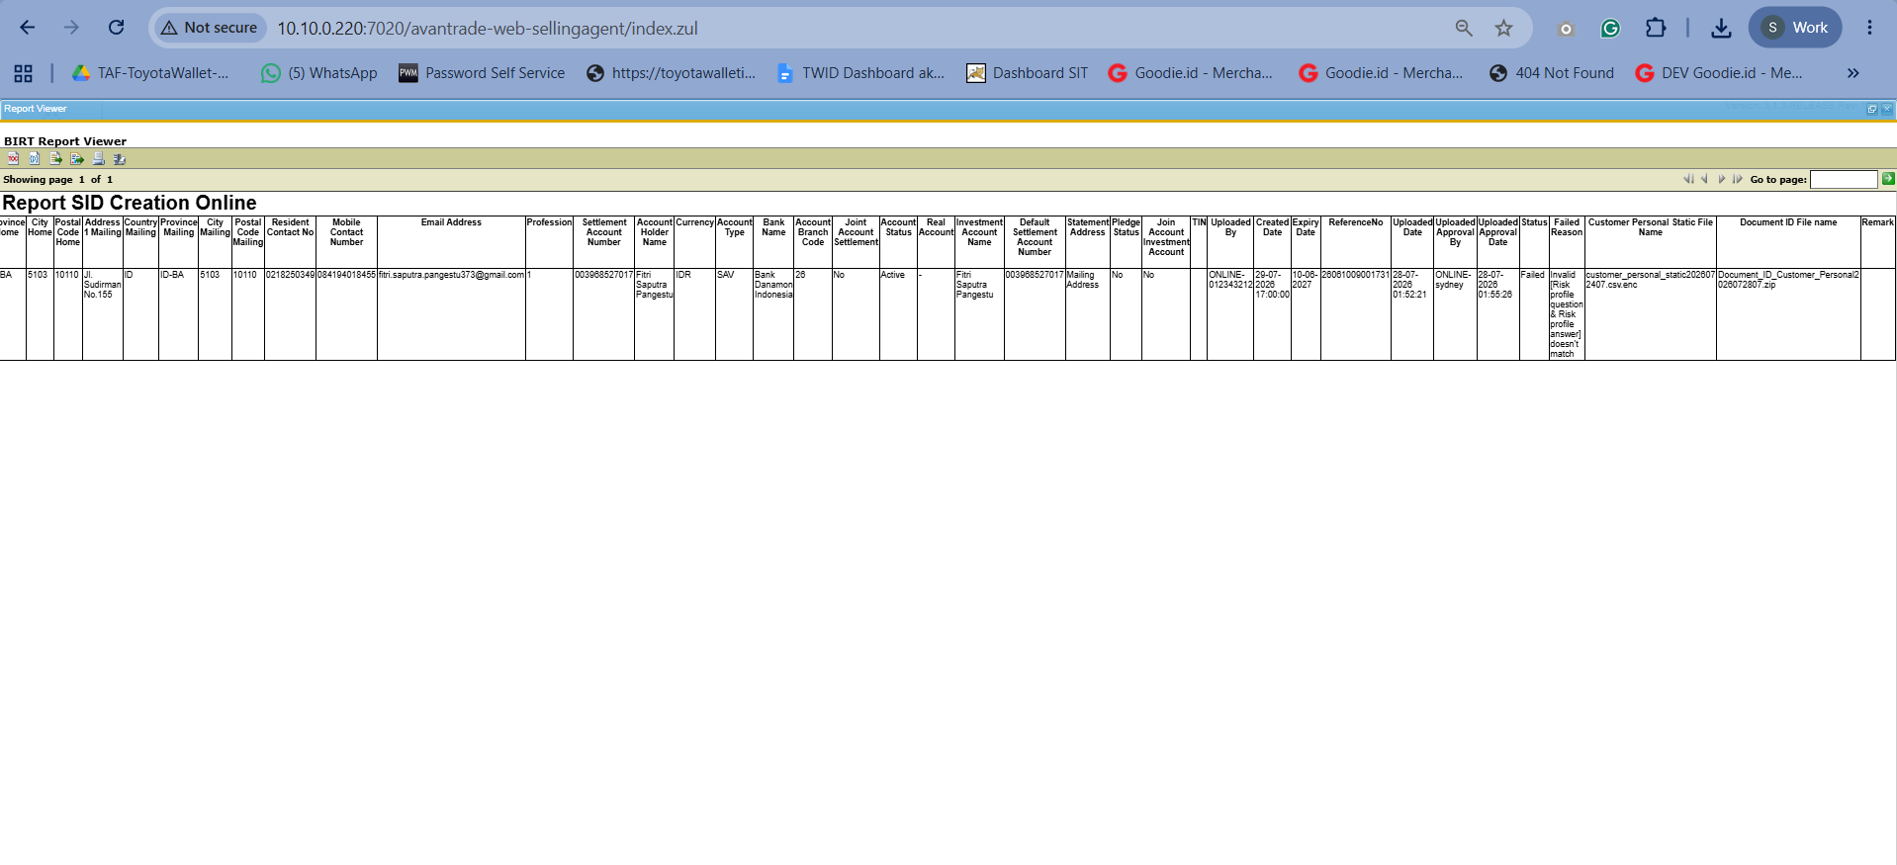

- Risk Profile Answer - Input format jawaban tidak sesuai (Risk Profile Answer = 1-2-3-4-5)
